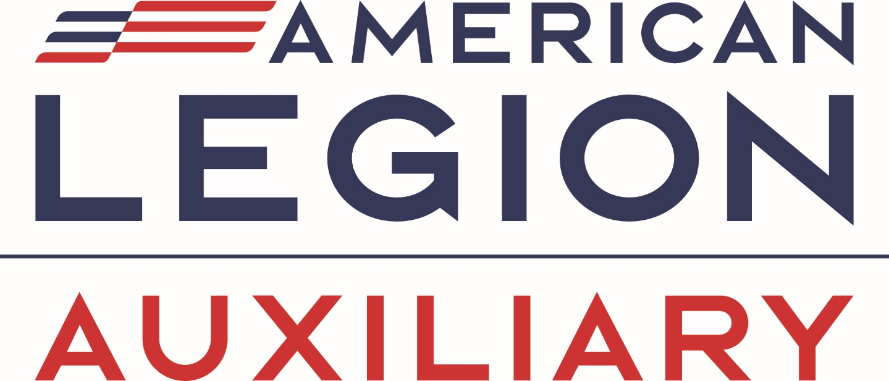
Non-Traditional Student Scholarship
2025 Application
DUE MARCH 1, 2025
Application closes at 11:59 PM Eastern

Scholarship details:
Five scholarships, in the amount of $2,000 each, will be awarded for 2025. One scholarship will be awarded in each of the five divisions of the American Legion Auxiliary based on a scoring rubric.
- CENTRAL DIVISION - Illinois, Indiana, Iowa, Kansas, Michigan, Missouri, Ohio, West Virginia, Wisconsin
- EASTERN DIVISION - Connecticut, Delaware, District of Columbia, Maine, Maryland, Massachusetts, New Hampshire, New Jersey, New York, Pennsylvania, Rhode Island, Vermont
- NORTHWESTERN DIVISION - Colorado, Minnesota, Montana, Nebraska, North Dakota, South Dakota, Wyoming
- SOUTHERN DIVISION - Alabama, Arkansas, Florida, Georgia, Kentucky, Louisiana, Mississippi, North Carolina, Oklahoma, Puerto Rico, South Carolina, Tennessee, Texas, Virginia
- WESTERN DIVISION - Alaska, Arizona, California, Hawaii, Idaho, Nevada, New Mexico, Oregon, Utah, Washington
All are gift scholarships, not loans.
Please contact Education@ALAforVeterans.org with questions. Due to the high number of scholarship applications received, the ALA National Headquarters staff and National Education Committee is unable to respond to application inquires to confirm receipt of materials.
https://legion-aux.formstack.com/forms/2025nontraditionalstudentscholarship

