AMERICAN LEGION AUXILIARY

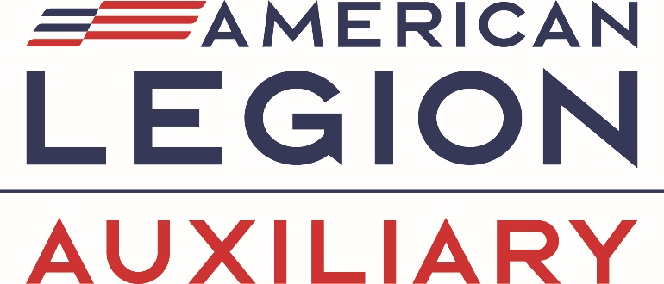

Spirit of Youth Scholarship
2025 Application
DUE MARCH 1, 2025
Application closes at 11:59 PM Eastern

Scholarship details:
State/Department: National Headquarters will award each state/department winner a $1,000 scholarship. This is relatively new and started in 2023-2024.
National: From the potential 52 state/department scholarship winners, the National Education Committee will select 5 winners (1 per division) based on a scoring rubric. These 5 winners will receive a $5,000 scholarship in lieu of the $1000 state/department scholarship.
- CENTRAL DIVISION - Illinois, Indiana, Iowa, Kansas, Michigan, Missouri, Ohio, West Virginia, Wisconsin
- EASTERN DIVISION - Connecticut, Delaware, District of Columbia, Maine, Maryland, Massachusetts, New Hampshire, New Jersey, New York, Pennsylvania, Rhode Island, Vermont
- NORTHWESTERN DIVISION - Colorado, Minnesota, Montana, Nebraska, North Dakota, South Dakota, Wyoming
- SOUTHERN DIVISION - Alabama, Arkansas, Florida, Georgia, Kentucky, Louisiana, Mississippi, North Carolina, Oklahoma, Puerto Rico, South Carolina, Tennessee, Texas, Virginia
- WESTERN DIVISION - Alaska, Arizona, California, Hawaii, Idaho, Nevada, New Mexico, Oregon, Utah, Washington

https://legion-aux.formstack.com/forms/2025spiritofyouthscholarship

