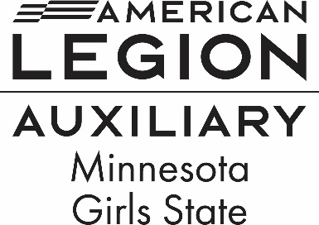

20 W 12th St #314, St. Paul, MN 55155

Phone: 651-224-7634

Email – [deptoffice@mnala.org](mailto:deptoffice@mnala.org)

“What is the American Legion Auxiliary Minnesota Girls State?” “What will these young women be experiencing during that week?” We hope the following information will answer some of your questions.

American Legion Auxiliary Minnesota Girls State is a program for young women who have just completed their junior year of high school. American Legion Auxiliary Minnesota Girls State is a week-long experience of learning about Minnesota government at the local, county and state levels by their participation in the process. It is a week of intensive study and involvement. The participants will organize and participate in the various levels and branches of government. Every girl will hold a government office or will become a member of the House or Senate.

Each girl is a citizen of a city, a county, and the state as well as a member of a political party. The week begins with instruction in city government, electing city officials and organizing their city government. Next is the county, followed by the state level. At each level, the citizens learn the election process and then actually elect, organize and carry on the business of government. They participate in precinct caucuses through state conventions to learn the political process.

Highlights of the week include campaigning, elections, Inauguration of the ALA MN Girls State Governor and State Constitutional Officers, debating bills in legislative sessions held in the House and Senate Chambers, and conducting Mock Trials in the Judicial Center at the Minnesota State Capitol in St Paul.

Unlike a summer or recreational camp, American Legion Auxiliary Minnesota Girls State is a week of studying and learning by involvement. Included in this mailing is a schedule of a typical day’s activities so you may see the type of program that is promoted and the pace expected of the citizens.

The citizens also have the opportunity for group living. For many, it will be their first exposure to dormitory living, sharing a room and/or bath facilities and limited access to a telephone. Meals are served in the University cafeteria. This week is a good preview of college dorm life.

The citizens have both an opportunity and a responsibility. The opportunity is participating in a program of government with some 400 other young women from throughout Minnesota. The responsibility is to learn as much as they can about government and sharing their gained knowledge and experience with their school and their community when they return home.

If you have any questions concerning the American Legion Auxiliary Minnesota Girls State program, please contact your local American Legion Auxiliary Unit or contact us at the address above.

We look forward to having a representative from your school participate in Minnesota Girls State June 15-21,2025

Wanda Prescher Peggy Tesdahl Amelia Tesdahl

Girls State Chairman Girls State Director Girls State Educational Director

Renee Seuss Jen Stolz Kollett Kaehlert

Girls State Committee Girls State Committee Americanism Chairman