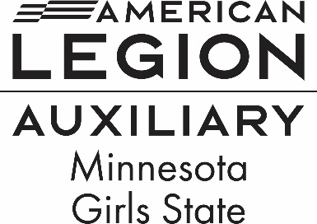

20 W 12th St #314, St. Paul, MN 55155
Phone: 651-224-7634
Email – deptoffice@mnala.org

Minnesota High Schools

We are sending this video along with more information on American Legion Auxiliary Minnesota Girls State. This national program is for any female in her Junior year of high school, interested in how our government works. The week- long program will be held at Bethel University from June 15-21, 2025. We encourage all responsible young women to apply. There is NO COST to the student and/or their family. All registration fees are covered by your local American Legion Auxiliary Unit who sponsors your student(s).
.
We ask that you send this information to your guidance counselors and teachers. We have Auxiliary members who would love to come and give a Girls State presentation to all interested young women.

We would love to have one of your students partake in this great program and have this opportunity to meet like-minded females from across our great State of Minnesota.

We Look forward to hosting a young lady(s) from your school this summer.

Any questions or concerns, please call me at 507-254-0304 / email:w.prescher1951@gmail.com

Wanda Prescher
Department of Minesota
American Legion Auxiliary
Girl State Chairman

