2024 Fall Conference
Special Guest Speaker
2024-2025 National American Legion Auxiliary
President Trish Ward

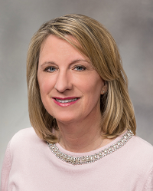

Fall Conference will once again be held at River’s Edge Conference Center in St. Cloud October 24-26, 2024. Besides our annual Poppy Contests and the awesome AEF Silent Auction we are excited to announce
Incoming 2024-2025 National President Trish Ward
will be speaking Thursday, October 24 at 6:30 p.m. in the main auditorium of the Convention Center.

The Department of Minnesota American Legion Family
is invited to hear Trish’s message. Trish is an engaging and dynamic speaker. You won’t want to miss it!

More details about Trish’s presentation will be available the week of September 1, 2024.

Registration and hotel information for Fall Conference follows.

