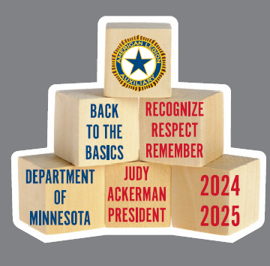
Department President 2024-2025
Judy Ackerman
judya2002@gmail.com

Theme: Back to the Basics – Recognize, Respect, Remember
Symbol: Building Blocks
Project:
Part 1 – Funds for Rehabilitation equipment for at least 4 of the veterans homes. The Kinevia Duo is a top priority for three of the homes. The cost for each of these could be up to $8,500 each. The 4th home has requested the Scifit stepper due to space limitations. The cost for this piece could be $6,500.00. Several of the other homes have smaller pieces of rehabilitation equipment on their list also.

Part 2 – Personal Hygiene Kits for the female veterans that come to the new Female Veterans clinic at the VA medical center that will be opening in the spring of 2025. I would like to see the Dept contribute 300 of these kits.

